PICTURE | P.K. (What I know) | Text | Clues in the text | Inference (Read between the lines, what is the author trying to say without saying it directly?)
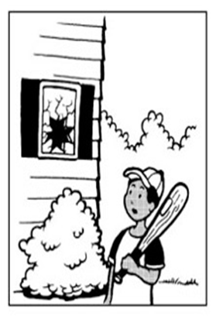 |  | Carlo gasped. Squeezing the bat tight in his hands, he could not take his eyes away from the window. His soul left his body as he watched the shattered pieces scattered on the ground.
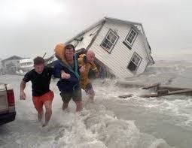 |  | There was no time to stop. I heaved and tried to catch my breath, pulling a cold and clammy hand along. My shoulders felt heavy, but I had to keep going.
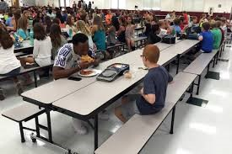 |  | Silence. No one wanted to make eye contact and a heavy atmosphere filled the cafeteria. Steve kept his head down and tried to make himself look as obscure as possible.

