Part 1.3 – Governance Policies – Conflict of Interest Policy
OTAHUHU INTERMEDIATE SCHOOL

conflict of interest policy
The standard of behaviour expected at Otahuhu Intermediate School is that all staff and board members effectively manage conflicts of interest between the interests of the school on one hand, and personal, professional, and business interests on the other. This includes managing potential and actual conflicts of interest, as well as perceptions of conflicts of interest.

The purposes of this policy are to protect the integrity of the school decision-making process, to ensure confidence in the school’s integrity, and to protect the integrity and reputations of staff and board members. Upon or before election or appointment, each person will make a full, written disclosure of interests, relationships, and holdings that could potentially result in a conflict of interest. This written disclosure will be kept on file and will be updated as appropriate.

In the course of meetings or activities, staff and board members will disclose any interests in a transaction or decision where their family, and/or partner, employer, or close associates will receive a benefit or gain. After disclosure, the person making the disclosure will be asked to leave the room for the discussion and will not be permitted to vote on the question.

Review schedule: Triennially
BOT MEETING REVIEWED: 24/09/2024
BOT MEETING APPROVED: 24/09/2024
Chris France 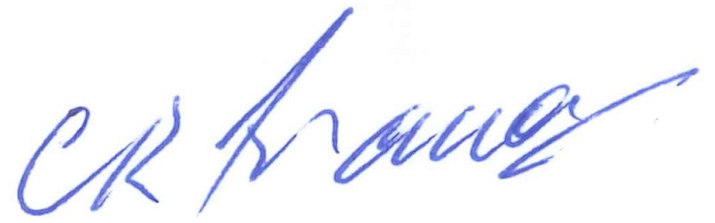Presiding Member
Date:

